Setting up your online EN 102 Grade Book
- Before setting up the grade book for your online EN 102 course, first set up all of your Turnitin assignments within each module. See the tutorial for How to Create Turnitin Assignments for EN 101 and 102 on the FWP website.

- Open your syllabus and ensure that you have the weights and grade breakdowns set correctly.

Papers/Projects, Word Counts, & Grade Distribution
Assignments | Word Count | Percentage Points
Reading Checklists, Surveys, and Course Introduction Quiz (10 @ .1% each) |  | 1%
Library modules (2 @ .5% each) |  | 1%
Discussions (7 @ 1% each) |  | 7%
Journals (9 @ 1% each) |  | 9%
Assignments (7 @ 1% each) |  | 7%
Draft Submission (4 @ 1.5% each) |  | 6%
Peer Reviews (4 @ 1.5% each) |  | 6%
Text Analysis Essay: Revision Submission | 800-1250 words | 15%
Annotated Bibliography: Revision Submission | 1000-1500 words | 15%
Argument Essay: Revision Submission | 1000-1500 words | 15%
Portfolio: Revision Submission | 700-1000 words (reflection letter)  Plus 2 revised essays | 18%
Total | 6500 words | 100%

- Next, go to your full grade center and click on the arrow next to the Total column. Click Edit column information.
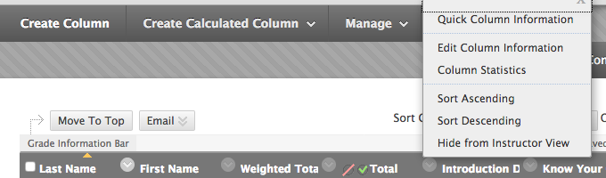

- At the bottom of the page, mark No for all options. Click Submit.
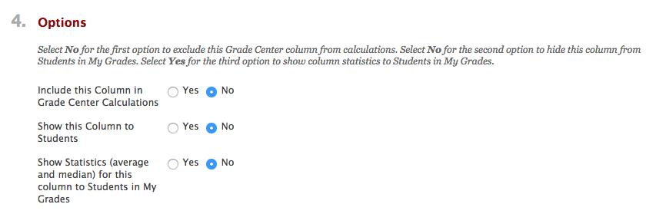
- Back in the full grade center, the Total column should now have a mark next to it indicating that students cannot view it. Leave this set for the semester so they do not mistake their total points for the course grade.

- Do the same for the Weighted Total column.

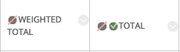

- Now click on the arrow next to Final and select Edit Column Information. Scroll down to Select Columns.
- Under Categories to Select, click on Surveys. Click on the move arrow to the right to move it into the box on the right.

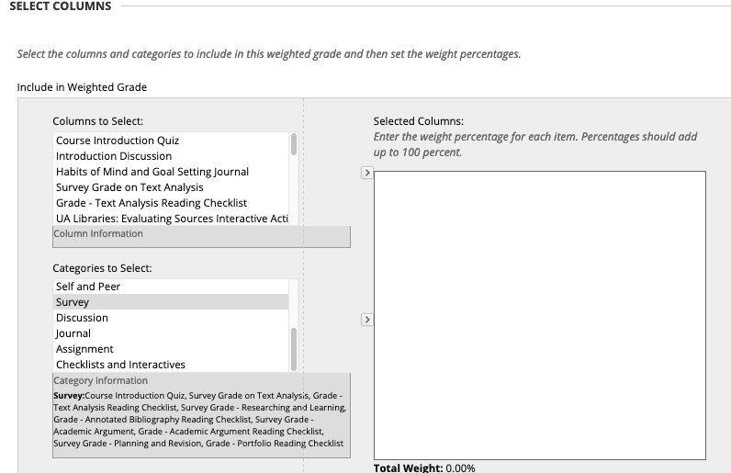

- Refer to grade breakdown on the syllabus (see #2 above). Surveys (know your course quiz, reading checklists, and surveys) are worth 1%. Enter the proper percentage.

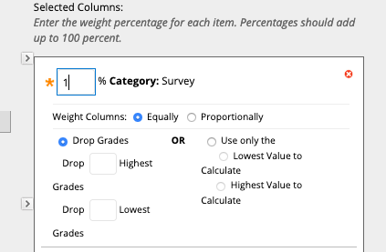
- In the top box (columns to select), locate each of the library modules. Each is worth .5%. Use the top arrow to move from the top box.
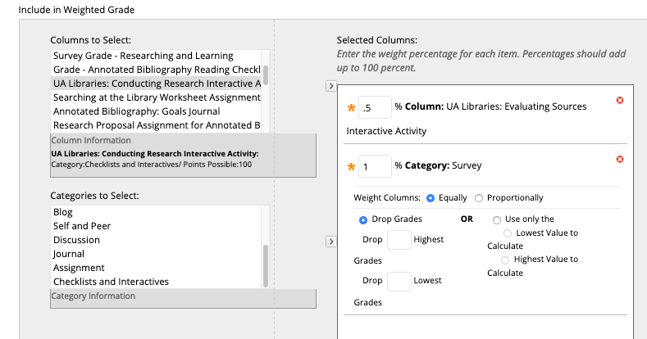

- Select the categories of Discussion, Journal, and Assignment. Assign the weights provided on the syllabus.
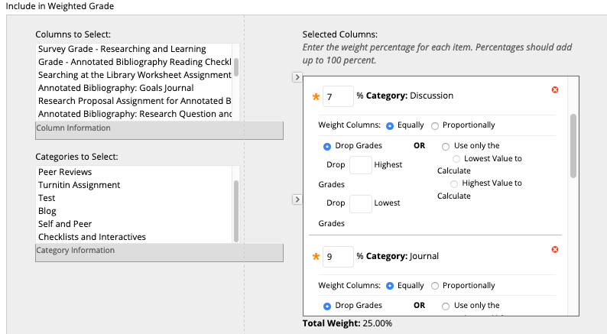

- Now it’s time to move each Turnitin assignment. Again, refer to the syllabus for how much each assignment is worth. Use the top arrow to move over each assignment and enter the correct percentage.
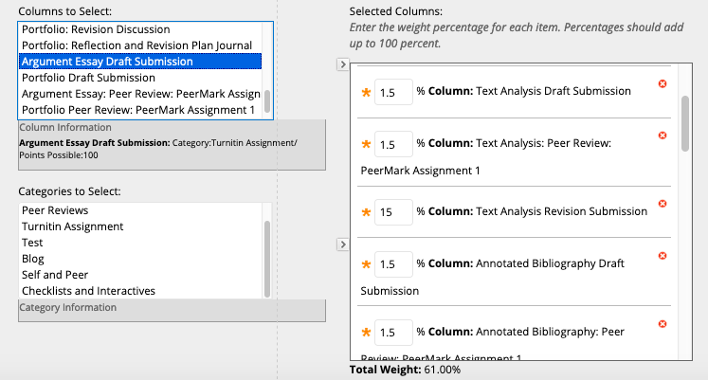

- When you are finished, the Total Weight should be 100.00%. If not, you have missed a category or assignment. (You may need to click elsewhere on the screen to get the last assignment to calculate.) Select YES to calculate grades as a running total.
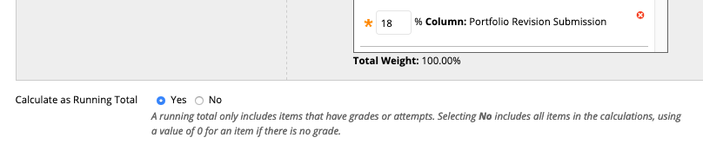
- Select Yes to include this column in grade center calculations and show this column to students. Click submit, and you’re finished! 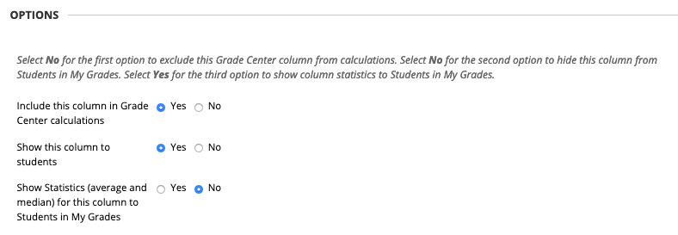
- To ensure that your grades appear in the order in which they appear on your course schedule, open your schedule in a new tab. In your full grade center, click on Manage and select Column Organization.
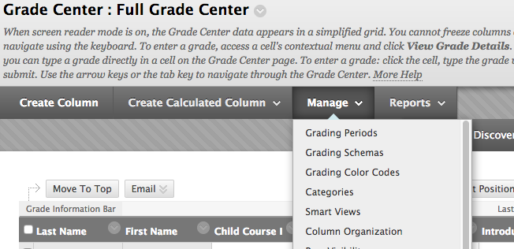

- Scroll down to Not in a Grading Period and use the move cursor to drag rows to the correct order. When you are finished, click Submit.
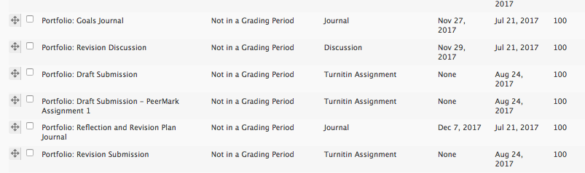

- If you need additional help, contact the Center for Instructional Technology (https://cit.ua.edu/contact/) or Natalie Loper (nloper@ua.edu).

