As you use the EN 101 Course Shell with your hybrid class, you may want to make some minor revisions to things like readings and discussion board assignments.

To edit, go to the content area you want to change and click the arrow beside the title. Then select “Edit”
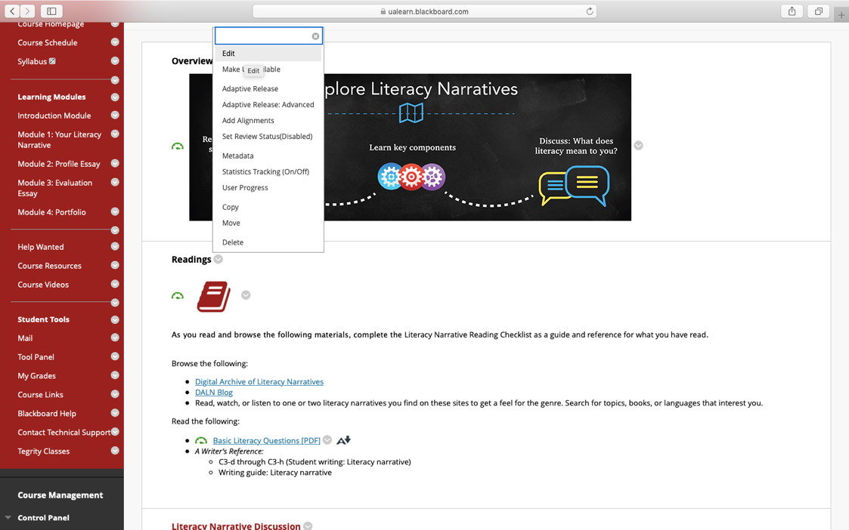

You’ll be taken to a screen that allows you to edit the text. When you’ve finished making your chances, click “Submit” on the bottom right of the screen.
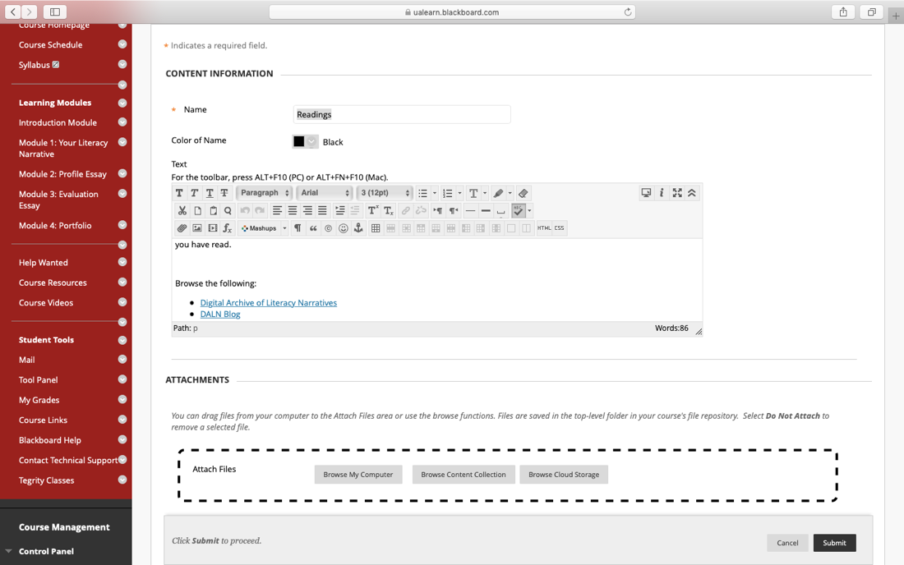

To edit a reading discussion prompt, you’ll need to go in and edit the first entry in the thread where instructions are posted.
Go to the Reading Discussion Content Area you want to edit and click the title.
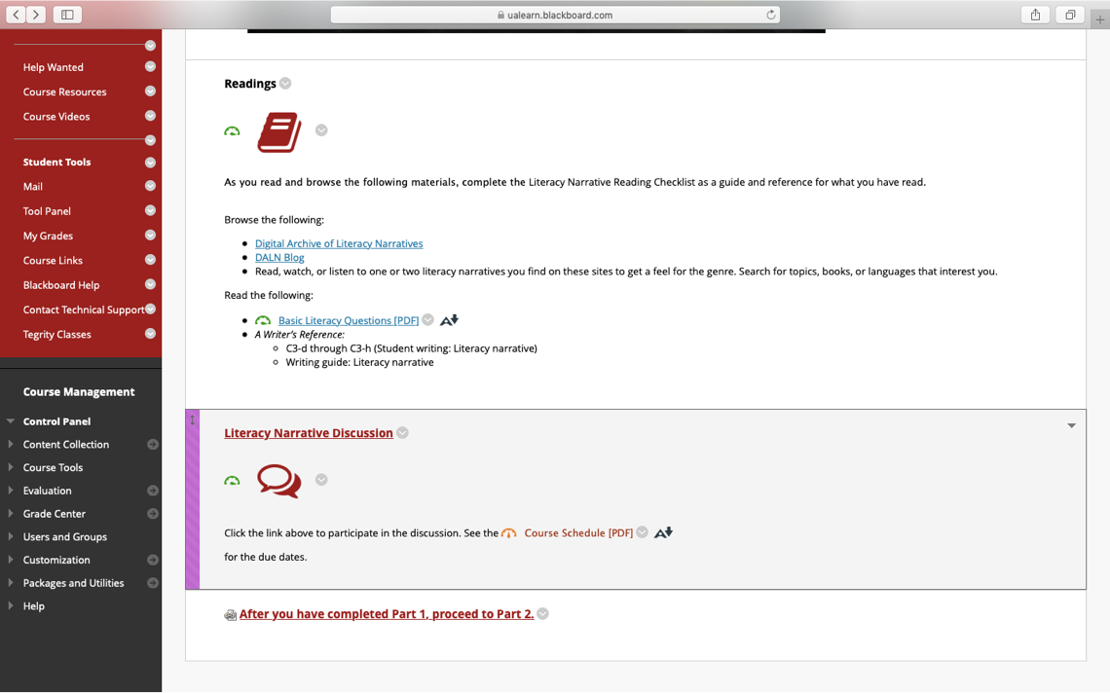

You’ll be taken to the discussion thread. Click that first post.

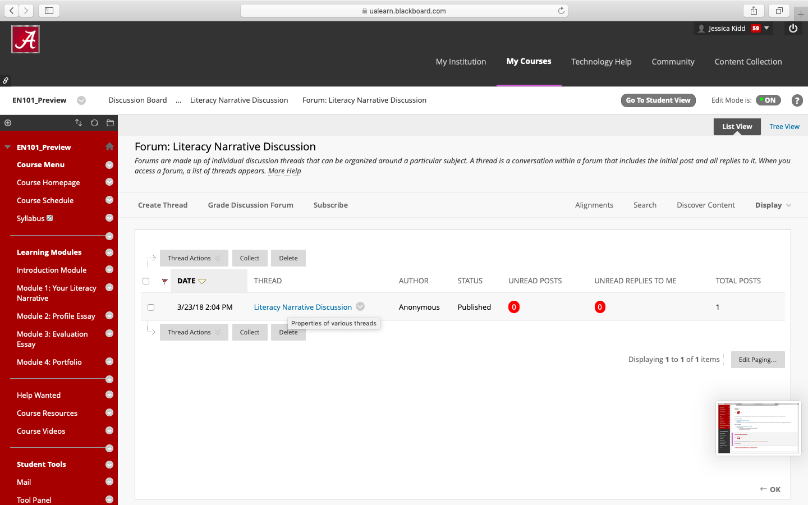

Click “Edit” at the bottom of the entry.
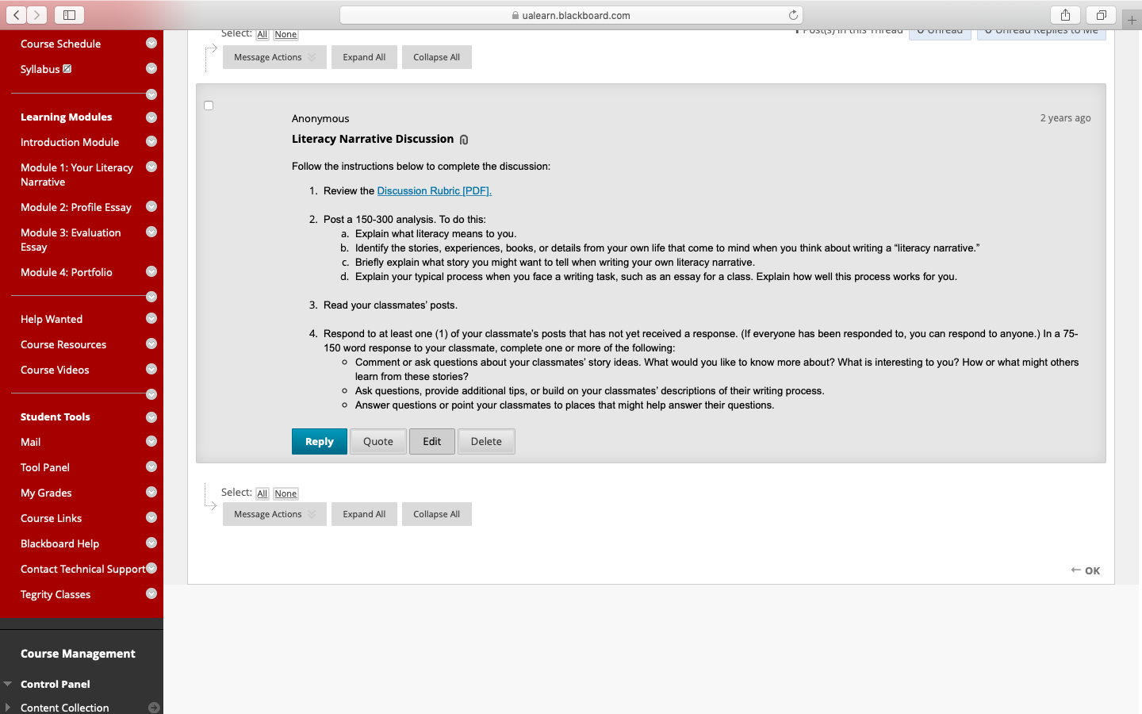

Edit the text as needed and click “Submit” on the bottom right of the screen.
