Setting up your online EN 102 Grade Book
- Before setting up the grade book for your online EN 102 course, first set up all of your Turnitin assignments within each module. See the tutorial for How to Create Turnitin Assignments for EN 101 and 102 on the FWP website.
- Open your syllabus and ensure that you have the weights and grade breakdowns set correctly.

Papers/Projects, Word Counts, & Grade Distribution
 | Word Count | Percentage Points
Library modules (2 @ 0.5% each) |  | 1%
Discussions (5 @ 1.6% each) |  | 8%
Journals (5 @ 1% each) |  | 5%
Assignments (7 @ 2% each) |  | 14%
Text Analysis Draft Submission and Peer Review | 800-1250 words | 3%
Annotated Bibliography Draft Submission and Peer Review | 1000-1500 words | 3%
Argument Essay Draft Submission and Peer Review | 1000-1500 words | 3%
Remix and Reflection Draft Submission and Peer Review (in a discussion board) | 500-750 words (Reflection)  Variable word count (Remix) | 3%
Text Analysis Essay: Revision Submission | 800-1250 words | 15%
Annotated Bibliography: Revision Submission | 1000-1500 words | 15%
Argument Essay: Revision Submission | 1000-1500 words | 15%
Remix and Reflection Submission | 500-750 words (Reflection)  Variable word count (Remix) | 15% (for reflection and remix together)
Total | ~6500 words (includes remix and drafts) | 100%

- Next, go to your full grade center and click on the arrow next to the Total column. Click Edit column information. (It might be at the very right end of your grade center and already be hidden from students.)
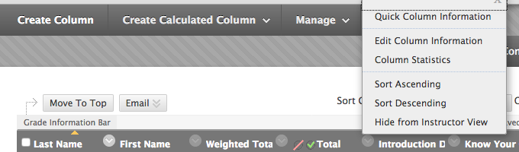

- At the bottom of the page, mark No for all options. Click Submit.
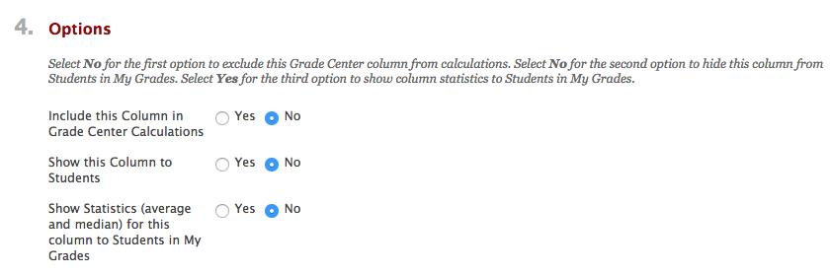
- Back in the full grade center, the Total column should now have a mark next to it indicating that students cannot view it. Leave this set for the semester so they do not mistake their total points for the course grade. (Note: this might have already been done in your class.)

- Now click on the arrow next to Weighted Total and select Edit Column Information. Scroll down to Select Columns.
- Under Categories to Select, locate Library Modules.
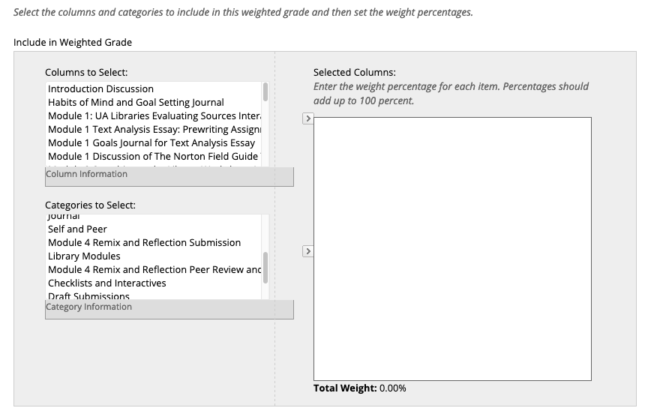
- Click on the arrow to the right to move it into the box on the right. Then, enter 1 in the % Column.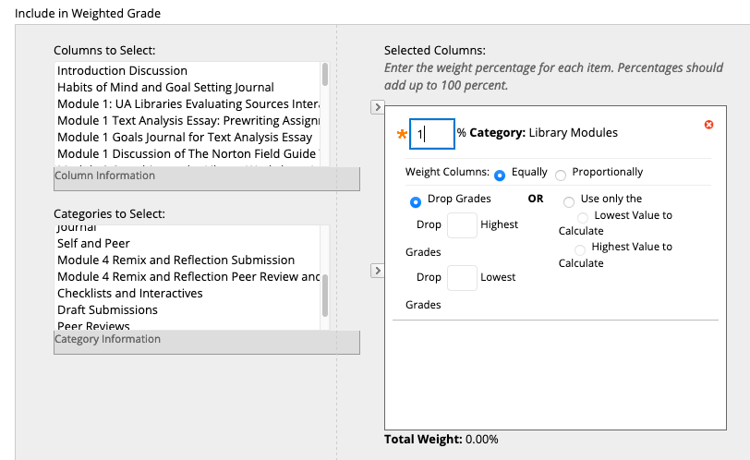
- Select the categories of Discussion, Journal, and Assignment. Assign the weights provided on the syllabus.
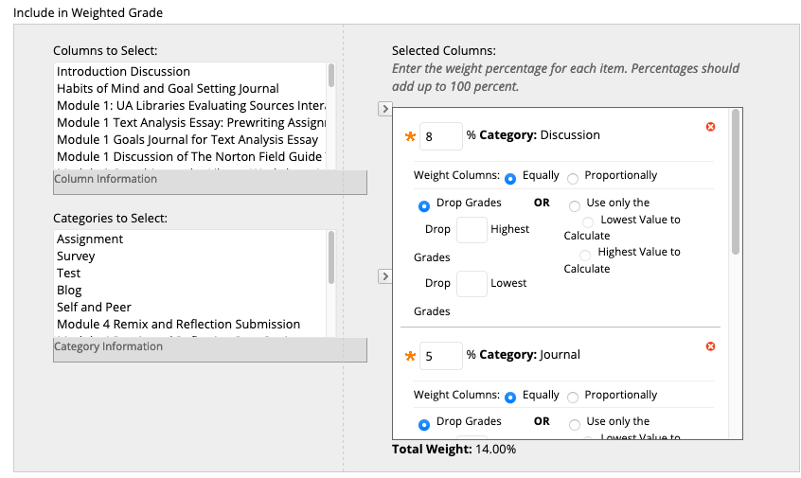

- Now it’s time to move each Turnitin assignment. Again, refer to the syllabus for how much each assignment is worth. Use the top arrow to move over each assignment and enter the correct percentage. Note: The PeerMark assignments will not show up as Turnitin assignments. They have been added as separate columns in the grade book, and those grades will be entered manually. (Peer reviews also will not appear in your “needs grading” area.) 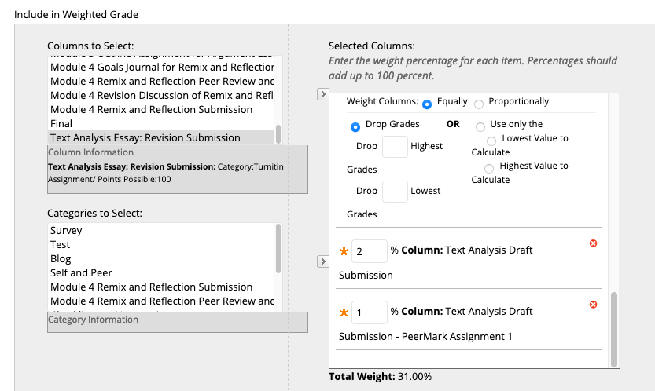

- When you are finished, the Total Weight should be 100.00%. If not, you have missed a category or assignment. (You may need to click elsewhere on the screen to get the last assignment to calculate.) Select YES to calculate grades as a running total.
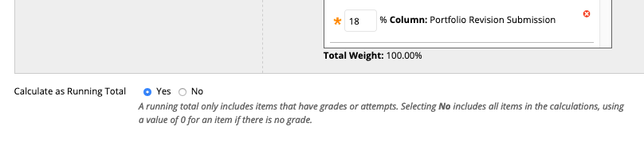
- Select Yes to include this column in grade center calculations and show this column to students. Click submit, and you’re finished! 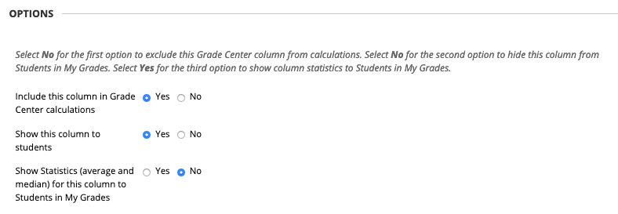
- To ensure that your grades appear in the order in which they appear on your course schedule, open your schedule in a new tab. In your full grade center, click on Manage and select Column Organization.
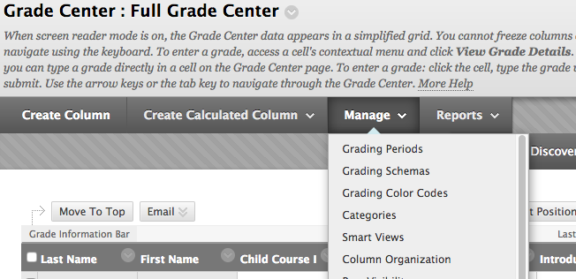

- Scroll down to Not in a Grading Period and use the move cursor to drag rows to the correct order. When you are finished, click Submit.
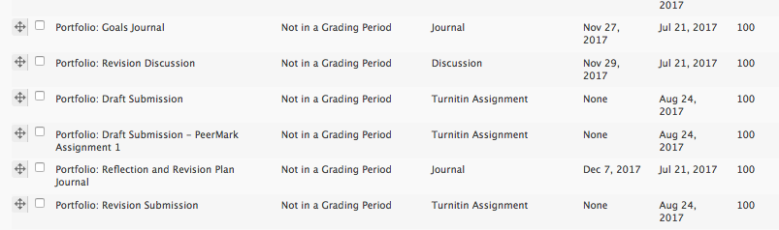

- If you need additional help, contact the Center for Instructional Technology (https://cit.ua.edu/contact/) or Natalie Loper (nloper@ua.edu).

