Setting up your online EN 101 Grade Book
- Before setting up the grade book for your online EN 101 course, first set up all of your Turnitin assignments within each module.
- Open your syllabus in a new tab and ensure that you have the weights and grade breakdowns set correctly.

Papers/Projects, Word Counts, & Grade Distribution
 | Word Count | Percentage Points
Discussions (7 @ 1.5% each) |  | 10.5%
Journals (5 @ 1.5% each) |  | 7.5%
Assignments (3 @ 2% each) |  | 6%
Draft Submissions and Peer Reviews (4 @ 4% each) | 800-1250 words each | 16%
Literacy Narrative: Revision Submission | 800-1250 words | 15%
Profile Essay: Revision Submission | 800-1250 words | 15%
Evaluation Essay: Revision Submission | 800-1250 words | 15%
Portfolio: Revision Submission | Variable word count (Revision)  700-1000 words (Reflection) | 15% (for entire portfolio)
Total | ~6500 words (includes drafts and revisions) | 100%

- Next, go to your full grade center and click on the arrow next to the Total column. Click Edit column information.
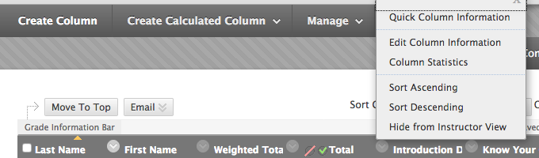

- At the bottom of the page, mark No for all options. Click Submit.
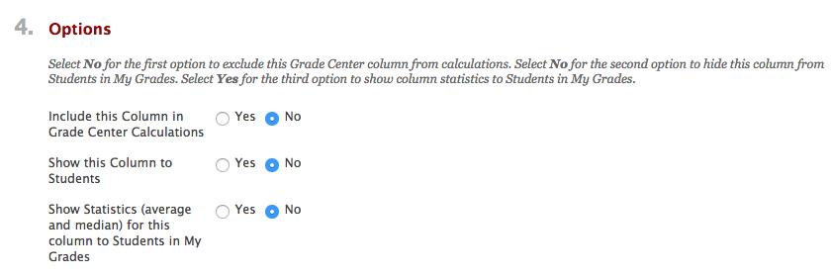
- Back in the full grade center, the Total column should now have a mark next to it indicating that students cannot view it. Leave this set for the semester so they do not mistake their total points for the course grade.

- Now click on the arrow next to Weighted Total and select Edit Column Information. Scroll down to 3. Select Columns.
- Under Categories to Select, click on Discussion. Click on the move arrow to the right to move it into the box on the right.
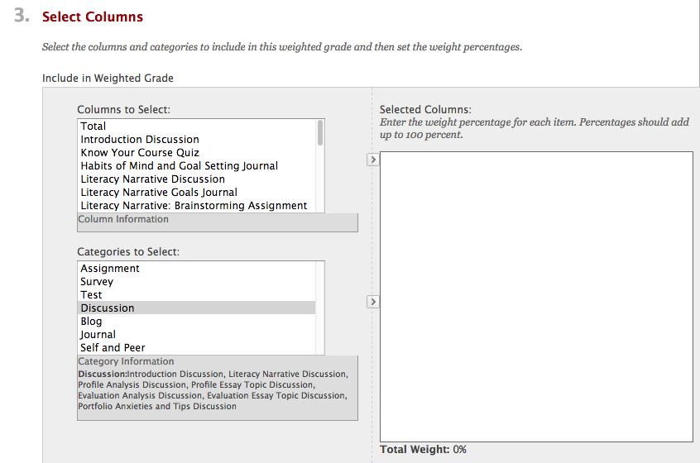

- Enter the correct weight, according to the syllabus.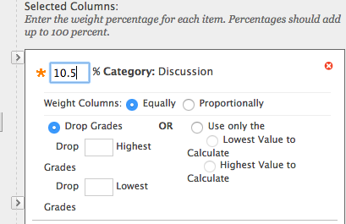

- Do the same for journal and assignment.
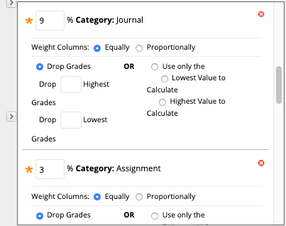

- Now it’s time for your Turnitin assignments. In the top box, locate each Turnitin assignment. Use the move arrow on top to move them into the box on the right. Enter the correct values for each assignment. Note: The PeerMark assignments will not show up as Turnitin assignments. They have been added as separate columns in the grade book, and those grades will be entered manually. (Peer reviews also will not appear in your “needs grading” area.) 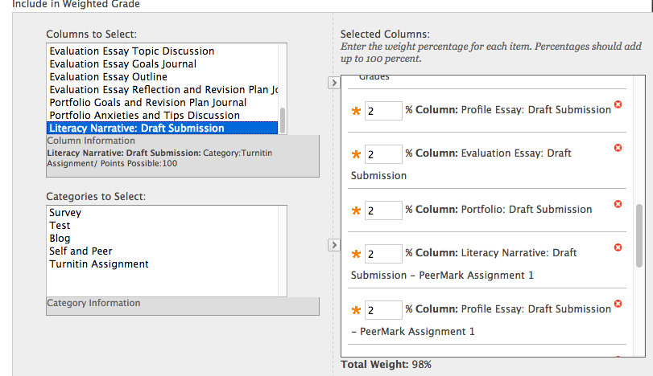
- When you are finished, the Total Weight should equal 100%. (You may need to click elsewhere on the screen to get the last assignment to calculate.) Select “Yes” under calculate as running total, include this column in grade center calculations, and show this column to students. Click submit, and you’re finished! 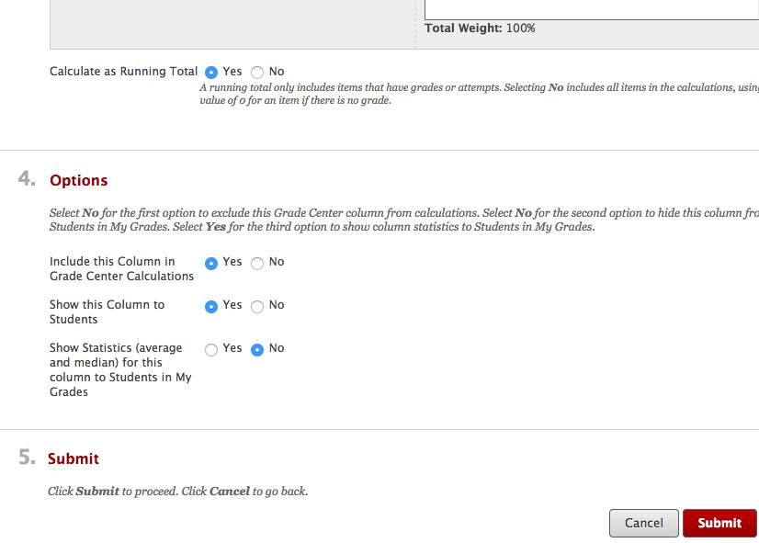
- To ensure that your grades appear in the order in which they appear on your course schedule, open your schedule in a new tab. In your full grade center, click on Manage and select Column Organization. 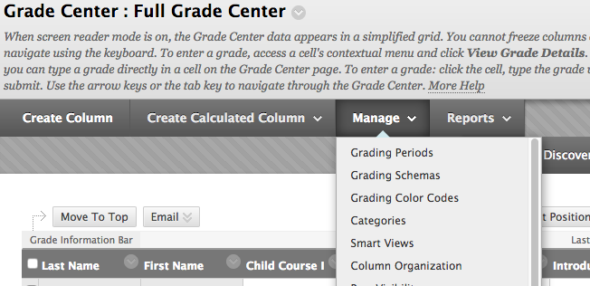

- Scroll down to Not in a Grading Period and use the move cursor to drag rows to the correct order. When you are finished, click Submit.

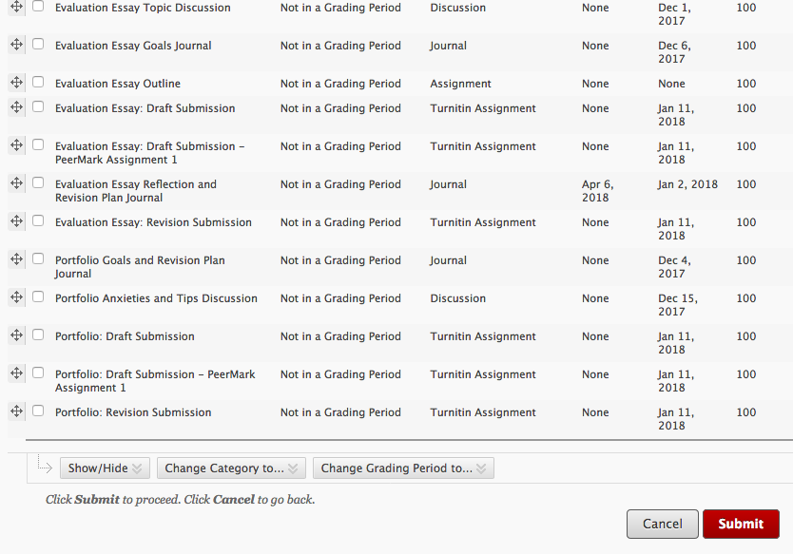

- If you need additional help, contact the Center for Instructional Technology (https://cit.ua.edu/contact/) or Ashley Palmer (aepalmer2@ua.edu).

